Guide How To Update AVO Via Github

1. Open Up Web Github

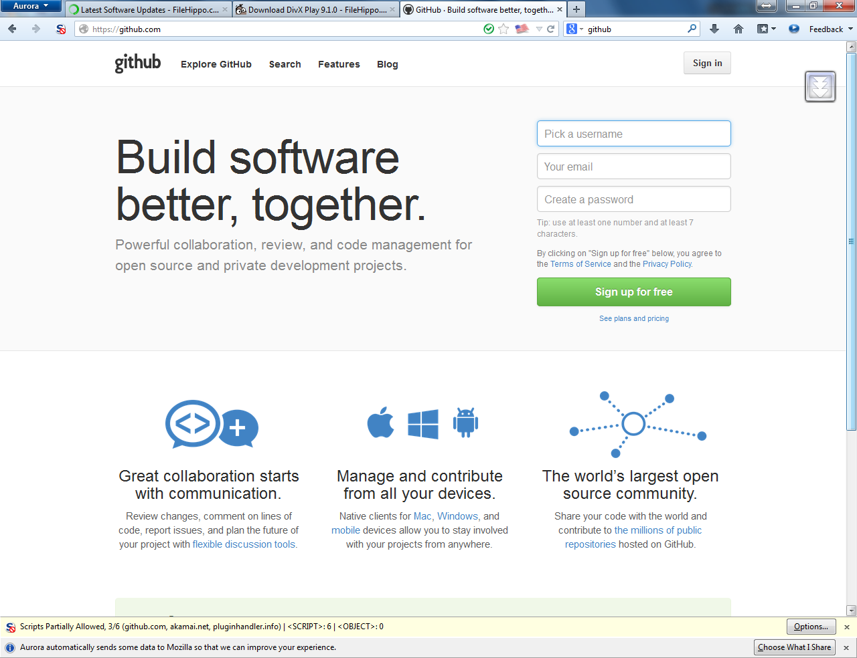

1. Just SignUp And Login

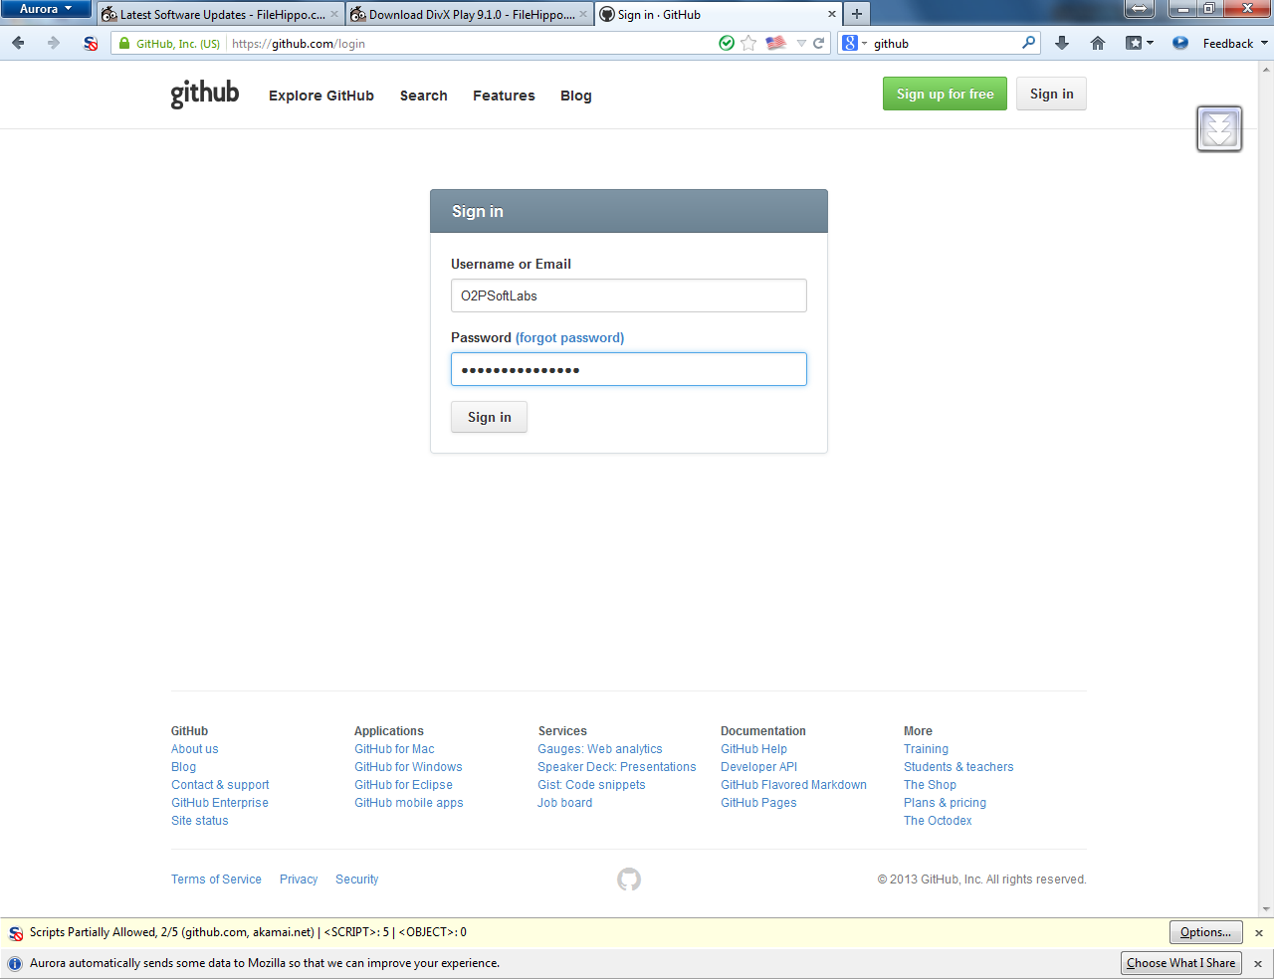

1. Don’t create repositories

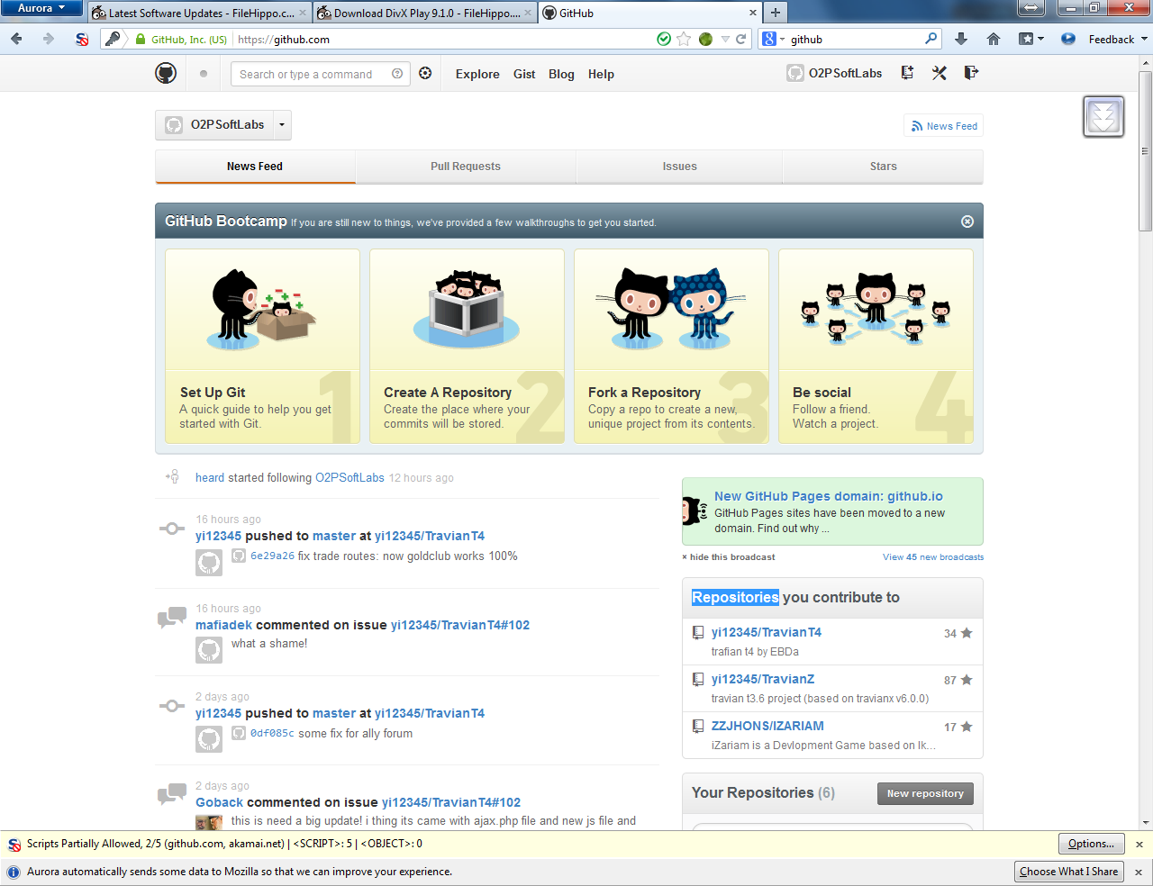

1. Search alveim online

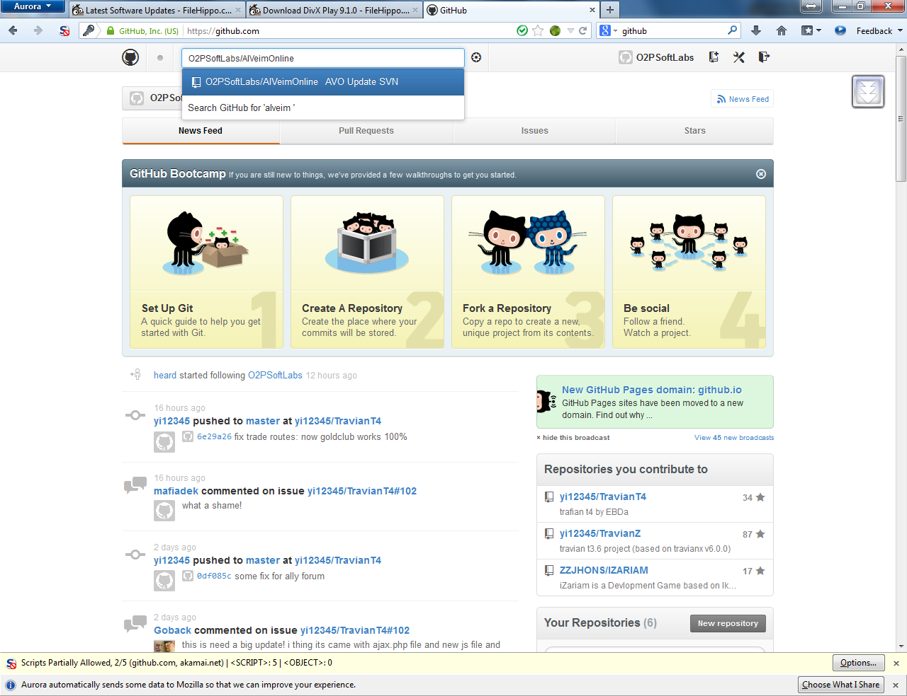

1. Do click so appear project. If you wanna download click Zip. But im not talk about it

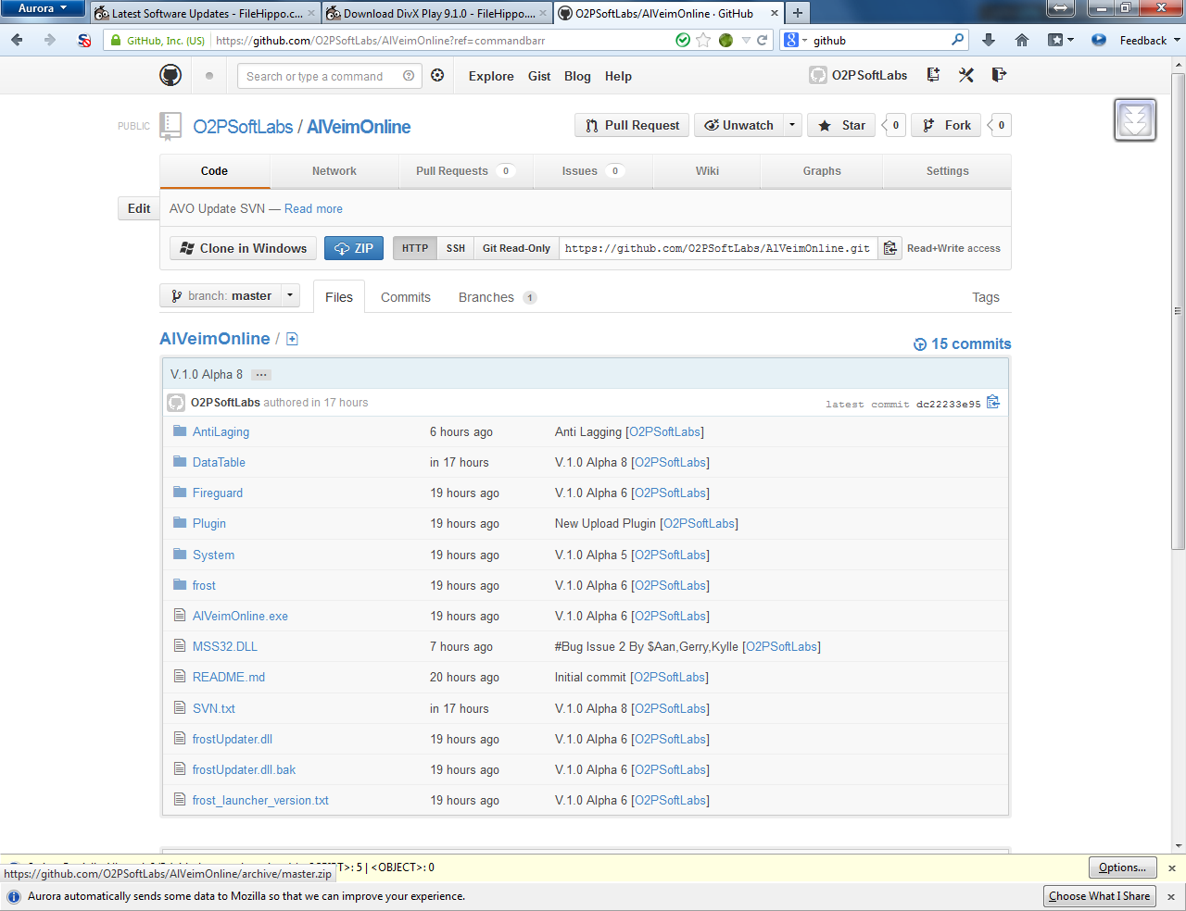

Skip This Step Go To

1. Project Better. Click Fork. After that all is ready just do that there appear like copy data to yours
2. Download The Git For Windows

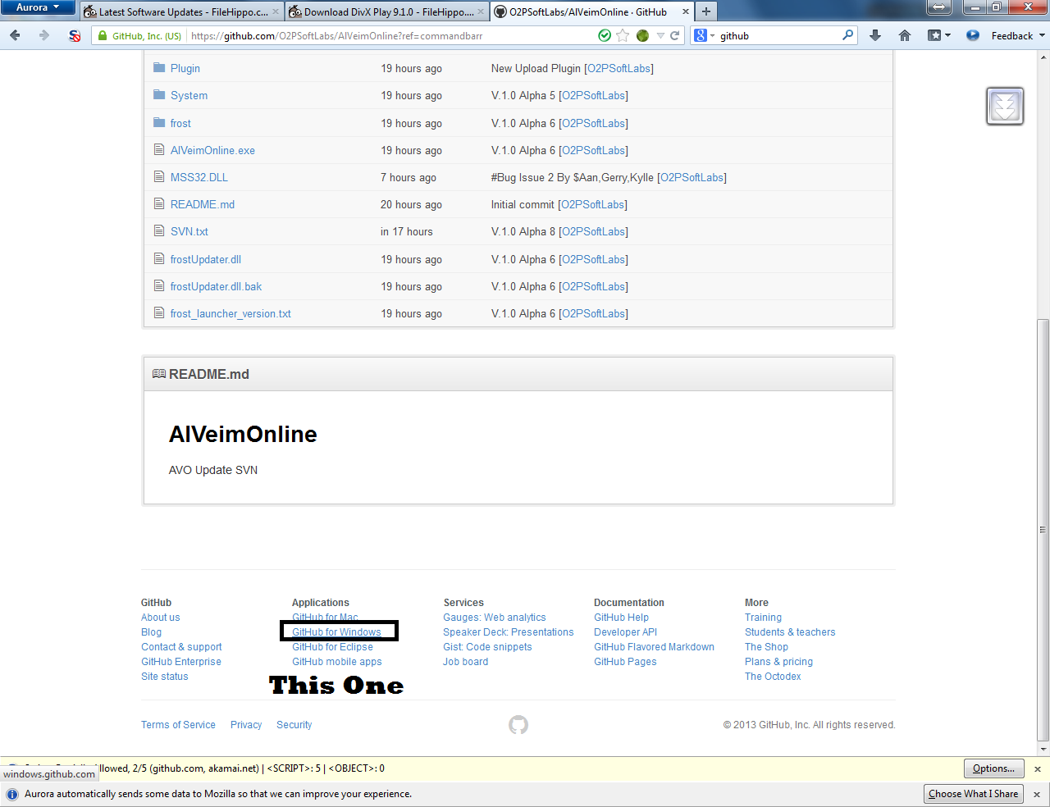

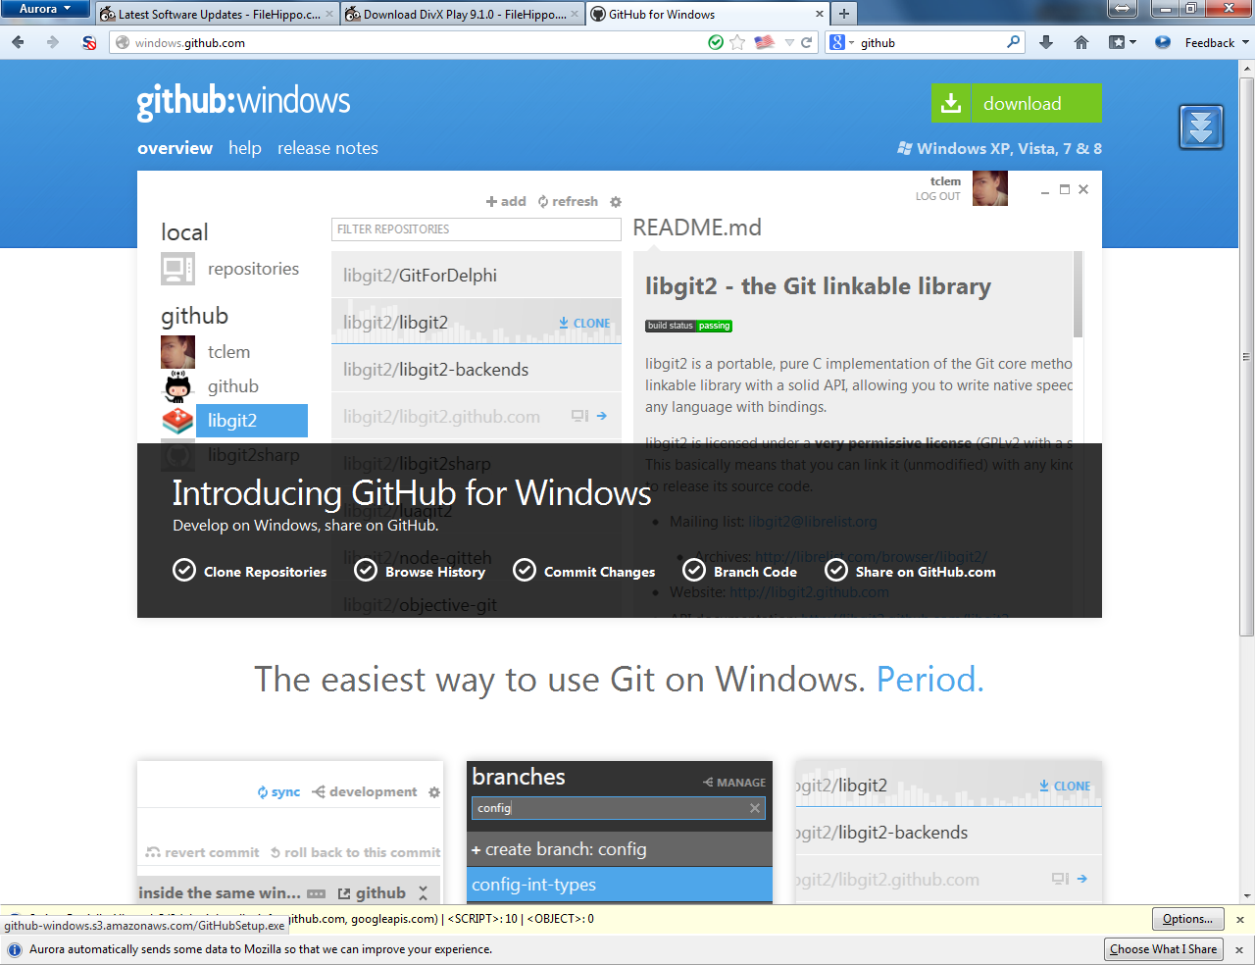

1. After install open UP!And Login(I love logo github NEKO!)

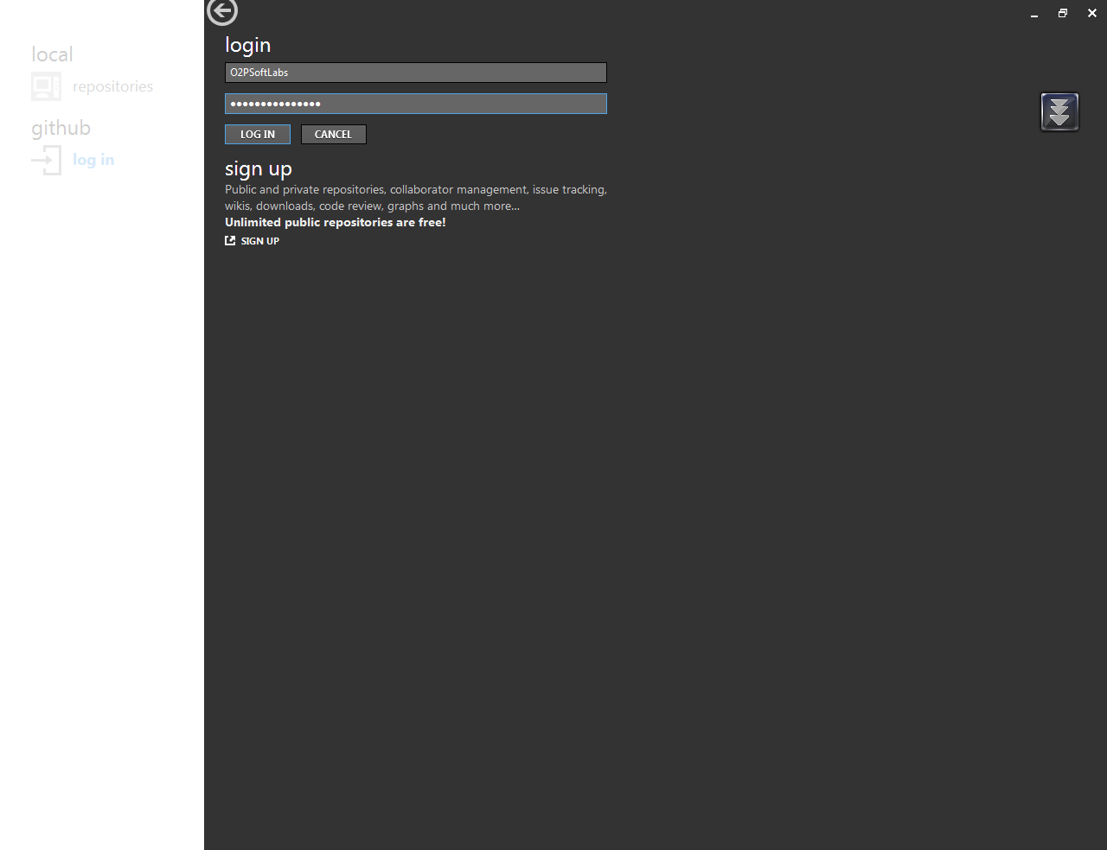

1. Go click account there is your poject now click clone or right click

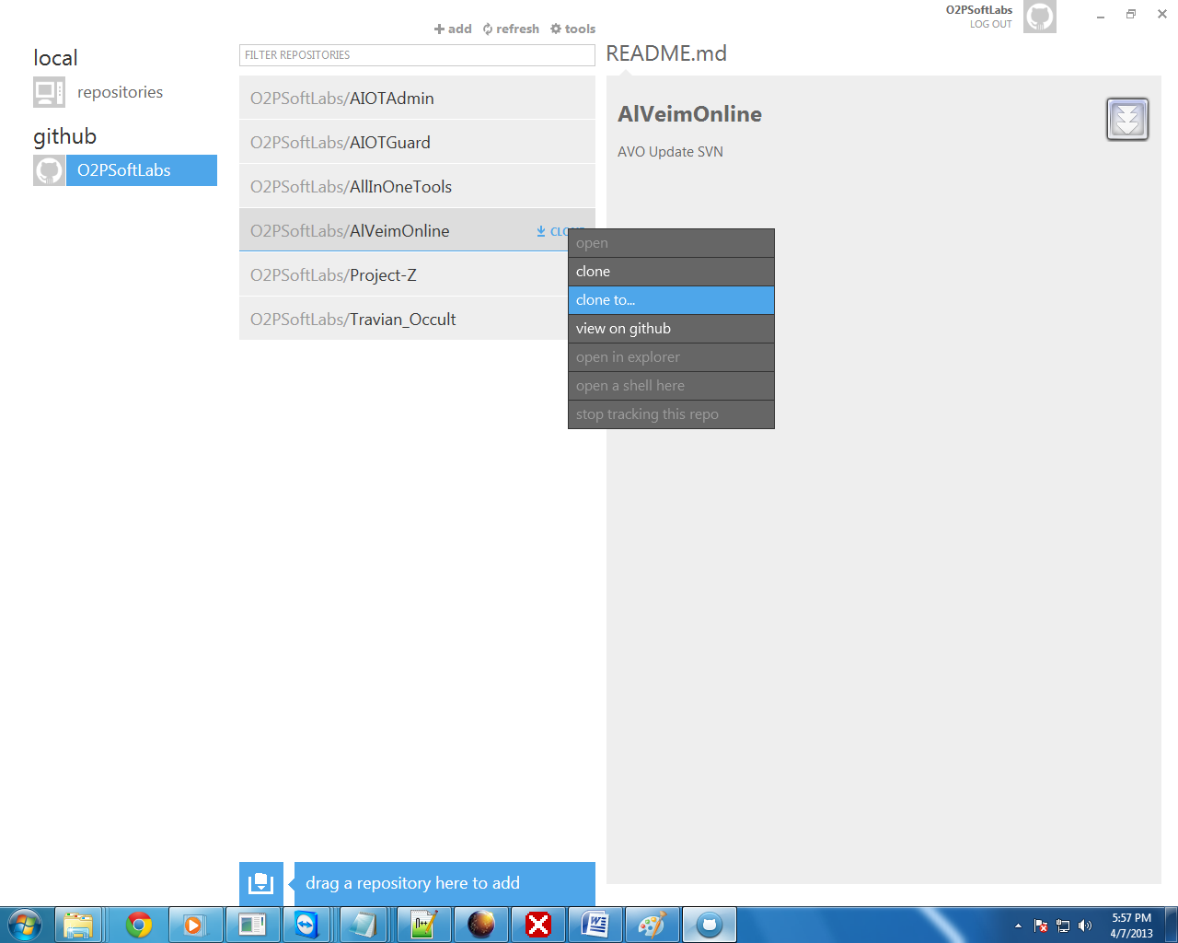

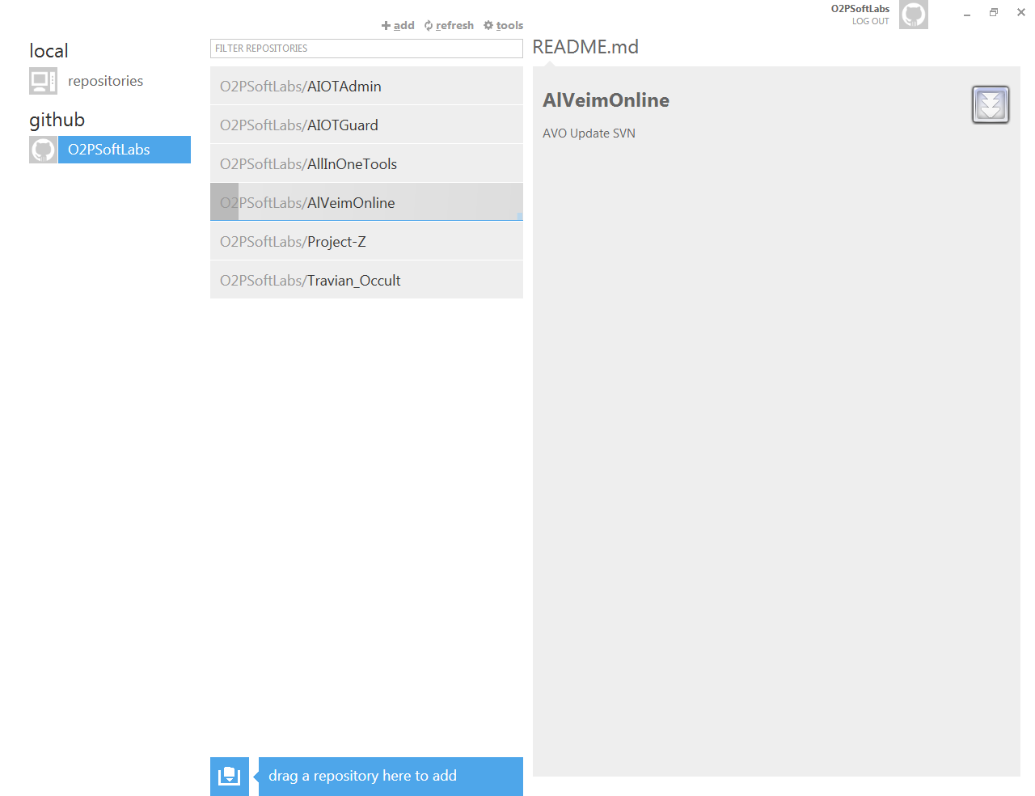

1. Next PM me :D